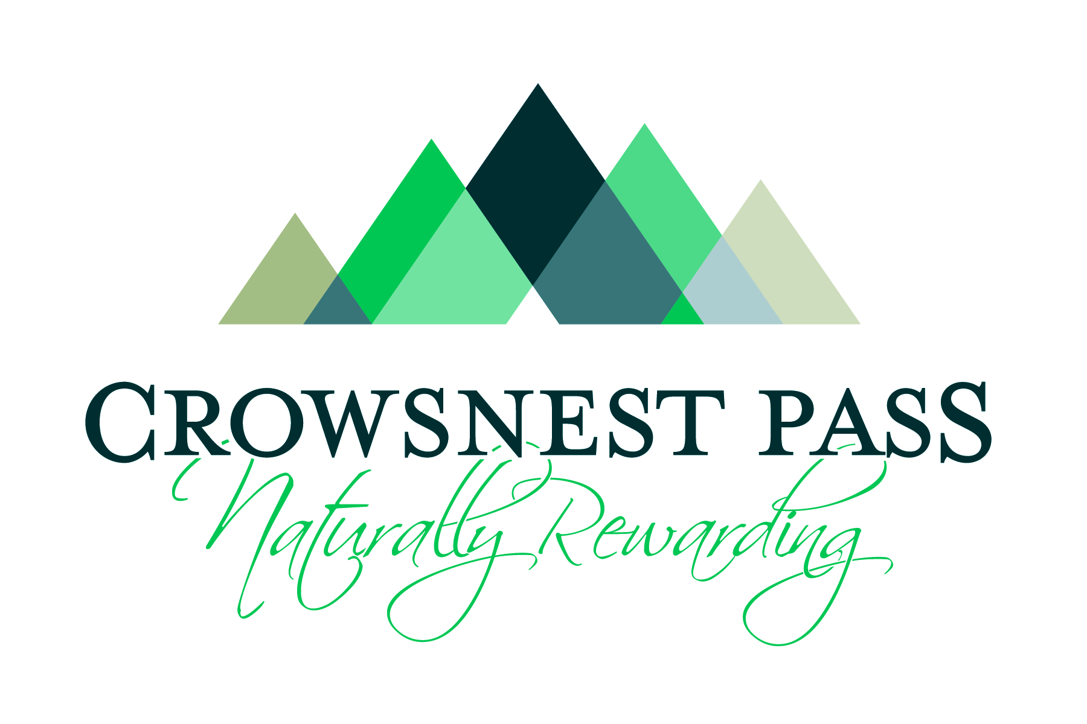 | Municipality of Crowsnest Pass Policy
Policy No.:  Policy Title:  Approval Date:  Revision Date:  Department: | 1204-02  User Conduct and Discipline Policy  22-September-2014  28-April-2016  Community Services – Parks and Recreation Authority

- POLICY PURPOSE
The purpose of this policy is:

- To protect the Municipality, Municipal assets, Municipal employees, and the general public;

- To provide a positive environment to engage in healthy and active lifestyles at Municipal Facilities and Programs;

- To provide restrictions and penalties for those responsible for vandalism and other inappropriate activity at Municipal Facilities and Programs; and

- To operate Municipal Facilities and Programs in a safe and responsible manner possible.

- DEFINITIONS
“Authority” means the Parks and Recreation Authority established by Municipal Bylaw.

“Booking” means an individual Facility time slot that is dedicated to a specific User. An example of a Booking is Minor Hockey on March 12, 2013 from 8:00am to 9:00am in the arena.

“Casual User” means a User that is not defined as a Regular User.

“Director” means the Director of the Municipality’s Community Services Department, or the employee(s) designated by the Director to implement this policy.

“Facility” means those Community Services Department operated venues that are available for User Bookings or Spontaneous Use, including Facility equipment, venues, and associated Facility grounds.

“Municipality” or “Municipal” means the corporation of the Municipality of Crowsnest Pass located in the Province of Alberta.

“Office” means the Community Services Offices located in the MDM Community Centre at 2802 – 222 Street in Bellevue, Alberta.
“Program” means any program that is directly offered and/or coordinated by the Community Services Department (e.g. fitness classes, swimming lessons, and public skating).

“Regular User” means a User that averages 1 or more Bookings per week for a given Facility.

“Rentals” are made up of either a single Booking or multiple Bookings.

“User” refers to anyone who wishes to use a Community Service Program or Facility.

- RULES AND REGULATIONS
General Rules
  - The following rules apply at all times to Users:

- Municipal personnel are to be respected, and their instructions are to be complied with.

- The use of any tobacco products is not permitted during Municipal Programs and in indoor Facilities.

- Any equipment not provided by the Municipality for use in indoor Facilities and Programs is subject to Municipal staff approval prior to use.

- Consumption of alcohol is only permitted within licensed Facility areas with written permission from the Director.

- Malicious and deliberate damage to Facilities will not be tolerated. Offenders will be reported to the proper authorities and required to pay for repairs.

- The Municipality is not responsible for lost, damaged, or stolen property belonging to Users or the general public. The Municipality is also not responsible for valuables left unattended.

- Abuse, harassment, and obscene language or behaviour will not be tolerated.

- Weapons are not permitted in Facilities.

- Skateboarding, biking, and roller blading are not permitted in indoor Facilities, excepting those designated for such use.

- Excepting written approval of the Director, the only animals permitted in indoor Facilities are those guide animals required for persons with disabilities.

- The Municipality will not be responsible for personal injury caused by negligence of Users or the general public.

- Persons suspected to be under the influence of drugs will be required to leave Programs or Facilities.

- Children under the age of 10 are not recommended to be left unattended in a Facility.

- Failure to comply with Municipal rules associated with Municipal Programs and Facilities can result in disciplinary action as provided for in this policy.

- If, in the opinion of staff, there is a concern with the behaviour, safety, or supervision of any person, that person may be directed by staff to leave a Facility. If the person in question is not an adult, the person’s guardian will be contacted prior to being asked to leave.

Arena Rules
  - In addition to the General Rules outlined herein, the following rules apply at all times to Users when in Municipal arenas:

- Adult Shinny is limited to those persons 13 years of age and older.

- Youth Shinny is limited to those persons less than 18 years of age.

- Helmets are recommended to be worn by all participants on the ice in the arena, but must be worn at all times when using a puck, ball, or a stick.

- Sticks, pucks, and balls are only permitted during shinny hockey and other Municipal approved Programs.

- Wearing skates in the bleachers and lobby without skate guards is not permitted.

- Horseplay or fighting is prohibited.

- Climbing or hanging on the boards or glass is not permitted.

- Food and drink are not permitted on the ice or playing surface unless specific permission is provided by the Director.

- DISCIPLINE GUIDELINES AND PROCEDURES
  - Any User that does not comply with the rules or exhibits inappropriate behavior may be instructed by staff to leave the Facility or Program for the day. Any User who is asked to leave and repeatedly refuses to comply will be suspended for 1 month.

  - An incident report will be filed for all incidents where a User is instructed to leave a Facility or Program for the day. The incident report will be reviewed by the Director, who may implement an additional suspension of up to 1 year in length in accordance with this policy.

  - Notwithstanding the number of offenses committed by a User, the Director may immediately implement a suspension of 1 month to 1 year in length if the offense is deemed to be severe in nature. Examples of severe offenses may include, but are not limited to, the following: theft, willful vandalism, assault, and any activities that significantly endanger staff and public safety.

  - A User who is deemed to have committed a moderate offense will be suspended for 1 week.

  - A User who is suspended for a 2nd moderate offense within a 1 year period of a previous offense will be suspended for a minimum of 1 month.

  - Any User who is suspended for a 3rd moderate offense within a 1 year period of a previous offense will be suspended for 4 months.

  - Any suspension longer than 1 month may be appealed to the Authority at the next scheduled meeting. A request for a Special Meeting of the Authority can be made, but will require a $200 appeal fee. The appeal decision of the Authority shall be final.

  - In addition to any applicable suspension outlined herein, any User suspended for vandalism will not have their privileges reinstated until the cost of repair is reimbursed to the Municipality.

  - Any User who is suspended from a Municipal Facility or Program may not access any Municipal Facility or Program for the duration of the suspension. The suspension extends to pass-based activities, admissions, spectating, Programs, school use, special events, Facility Rentals, and participation with organized sport and community groups. Any User under suspension is not entitled to a refund or credit for any period of lost services as a result of the suspension, and the Municipality assumes no liability for the suspension of access and services to the suspended User.

MUNICIPALITY OF CROWSNEST PASS

Sheldon Steinke, Chief Administrative Officer

